DAT602

Assignment 2

Regan Zohrab

2021

Contents

1.0 Game Description 2

1.1 Base Idea 2

1.2 Logging in 2

1.3 Game Lobby 2

1.4 Gameplay 2

1.4.1 Objective and Scoring 2

1.5 Administrators 2

2.0 Storyboards, Screen Design and Rational 2

2.1 Login/Registration Screen 3

2.2 Character Selection 5

2.3 Game Screen 6

2.4 Admin Screen 7

2.5 Update player info screen 8

3.0 Entity Relationship Diagram 9

3.1 Entity Relationship Diagram Rational 9

3.1.1 Player, Player_Session, Session 9

3.1.2 Player, Player_Character, Character 9

3.1.3 Character, Character_Tile, Tile 9

4.0 CRUD Table 10

4.1 CRUD Analysis 11

5.0 SQL 11

5.1 DDL 11

5.1.1 Tables 11

5.2 Test Data and Queries 11

Milestone 1

# 1.0 Game Description

## 1.1 Base Idea

Jake and Blake Snake is a turn-based take on the game snake. Players choose either Jake or Blake and take turns moving the snakes across the map to eat the Juicy Nugget. Players must make a move within five seconds or it’s the next players turn. When a player eats the Juicy Nugget, their character grows by one square. Once a player has eaten 5 Juicy Nuggets, the player wins the game.

## 1.2 Logging in

When players enter the game, they are presented with a login screen. Existing players will be able to enter the game by entering in their username and password. When the player clicks the submit button the username and password will be checked against the database. If the username and password are entered incorrectly, they will be locked out. If a new player wishes to play the game, they click the new user button. They are then taken to the registration screen where they can choose a username and enter in a password, they enter in an email address then click the button create. The new player is then entered into the database and then taken to game lobby.

## 1.3 Game Lobby

Players choose either Jake or Blake as a character. Players are then taken to the game map where they will be placed with a waiting player who has chosen the other character or placed on the map to wait for another player.

## 1.4 Gameplay

Players will be given a 5 second count down and then the game begins. One player will be randomly chosen to start, they will have five seconds to choose the direction in which their charter moves, it is then the other players turn.

### 1.4.1 Objective and Scoring

The objective for the players is to guide their snake towards the Juicy Nugget, once a player has eaten the nugget the players snake will grow by one square in length. Opposing players cannot cross the other players snake tail, so this can be used to trap other players. If a player touches the other players tail, the game will end with the other player winning. Also, the game will end once a player has eaten five Juicy Nuggets. Players wins will be recorded in the database.

## 1.5 Administrators

Administrators are players with more privileges than other players. This will give them admin controls that allow them to kill existing games, edit player details such as passwords and usernames. They can also delete accounts and perform account unlocks for players who have been locked out.

# 2.0 Storyboards, Screen Design and Rational

## 2.1 Login/Registration Screen

|  |
| --- |
|  |
| 1. Enter Username  2. Enter Password  3. Register New User  4. Submit Username and Password to log in |
| I wanted the design on the screens and the game to be as simple as possible, and to be able to navigate without too many written instructions. The login screen consists of two boxes where the user can enter a username and password and then submit or click the new user button of they are new. |
|  |
| 1. Enter email address  2. Enter username  3. Enter password  4. Click button to create. |
| Going with the simple design, new players will enter the details needed in the text boxes then click create. |

## 2.2 Character Selection

|  |
| --- |
|  |
| 1. Jake Image  2 . Blake Image  3. Select Jake Button  4. Select Blake Button |
| This screen keeps stays with the same aesthetic. This screen shows the images of the characters that can be chosen (Jake or Blake). Images haven’t been decided on yet but can be added later. |

## 2.3 Game Screen

|  |
| --- |
|  |
| 1. Time Tag  2. Current Play Time  3. Image of Jake  4. Image of Blake  5. Jake moveable character  6. Blake moveable character  7. Juicy Nugget  8. Game grid |
| The game (map) screen consists of 3 main areas. The time, this shows the current time the game has taken. The player section that has the images of the two players. These images will light up when it is the players turn, this will change every 5 seconds. Finally, is the grid map. This is a 10x10 grid where the game will be played. I thought that having a map size of 10x10 would be big enough for players to use some strategy, but not too big so the games would take a long time to play. |

## 2.4 Admin Screen

|  |
| --- |
|  |
| 1. List of active players  2. Add new player button  3. Kill game Button  4. Remove player button  5. Update player info button. |
| The Admin screen will be only available to players who have an administrator status. The screen will show the list of connected players on the left of the screen. By selecting a player from the list, an administrator will be able to perform the functions indicated by the buttons. |

## 2.5 Update player info screen

|  |
| --- |
|  |
| 1. Player being updated  2. Total Wins  3. Player Username  4. Current Password  5. Email address. |
| The update player screen is where info on the players is updated, by entering in a new username, password or email and clicking the save button, the info will be saved. |

# 3.0 Entity Relationship Diagram

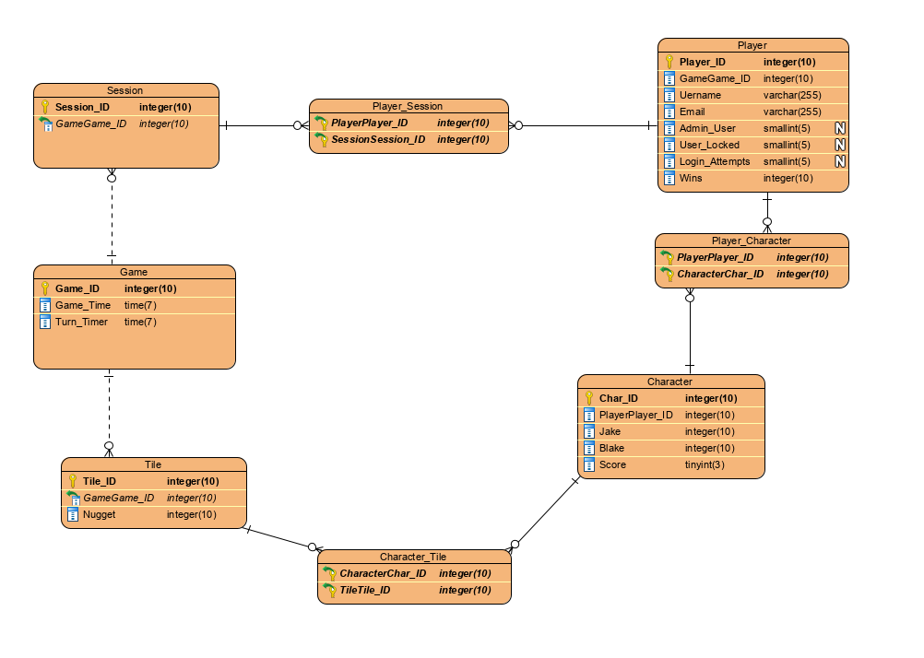

## 3.1 Entity Relationship Diagram Rational

### 3.1.1 Player, Player_Session, Session

The player table will hold information on the character such as account information and game stats. A session ID is then created. Because there can be many players that can join many game sessions a join table was created so the data can be normalized.

### 3.1.2 Player, Player_Character, Character

The Player, Character relationship is the same as Player and Session relationship where many players can choose from many (2) character so a join table was created. The Player table contains two columns for the two selectable characters, the rows will contain is the character is active, position on the grid, size, score and turn

### 3.1.3 Character, Character_Tile, Tile

Another join table was created as many players can be on many tiles. The Tile table contain information on the tiles, this contains 1 column which is Tile_ID. The rows will contain what tiles are activated when a character moves onto them, also which tile contains the Nugget, and what tiles will be set as the home (starting) tiles.

‘

### 3.1.4 Tile, Game

The game table consists of a game ID that contains total time, turn timer. The tiles are then associated with the game.

# 4.0 CRUD Table

|  |  |  |  |  |  |  |  |  |  |  |  |  |  |  |  |
| --- | --- | --- | --- | --- | --- | --- | --- | --- | --- | --- | --- | --- | --- | --- | --- |
| Entity/Attribute | **Check Username in Database** | **Register New User** | **Check Password against Username** | **Lock Account** | **Successful Login/Lobby Loads** | **Start New Game** | **Join Existing Game** | **Player Moves** | **Game Ends** | **Player Logs Off** | **Open Admin Console** | **Admin Kill Running Game** | **Admin Delete Player** | **Admin Creates New Player** | **Admin Edits Existing Player Info** |
| **Player** |  |  |  |  |  |  |  |  |  |  |  |  |  |  |  |
| Player ID |  |  |  |  |  |  |  |  |  |  |  |  |  |  |  |
| Username |  |  |  |  |  |  |  |  |  |  |  |  |  |  |  |
| User Password |  |  |  |  |  |  |  |  |  |  |  |  |  |  |  |
| Email |  |  |  |  |  |  |  |  |  |  |  |  |  |  |  |
| Locked User |  |  |  |  |  |  |  |  |  |  |  |  |  |  |  |
| Admin User |  |  |  |  |  |  |  |  |  |  |  |  |  |  |  |
| Login Attempts |  |  |  |  |  |  |  |  |  |  |  |  |  |  |  |
| Wins |  |  |  |  |  |  |  |  |  |  |  |  |  |  |  |
| **Player/Session** |  |  |  |  |  |  |  |  |  |  |  |  |  |  |  |
| Player/Player ID |  |  |  |  |  |  |  |  |  |  |  |  |  |  |  |
| Session/Session ID |  |  |  |  |  |  |  |  |  |  |  |  |  |  |  |
| **K**  **.j,k**  **Jlmnk;mkkylu’iujupiky7[6Session** |  |  |  |  |  |  |  |  |  |  |  |  |  |  |  |
| Session ID |  |  |  |  |  |  |  |  |  |  |  |  |  |  |  |
| **Game** |  |  |  |  |  |  |  |  |  |  |  |  |  |  |  |
| Game ID |  |  |  |  |  |  |  |  |  |  |  |  |  |  |  |
| Session/Session ID |  |  |  |  |  |  |  |  |  |  |  |  |  |  |  |
| Game Time |  |  |  |  |  |  |  |  |  |  |  |  |  |  |  |
| Turn Time |  |  |  |  |  |  |  |  |  |  |  |  |  |  |  |
| **Tile** |  |  |  |  |  |  |  |  |  |  |  |  |  |  |  |
| Tile ID |  |  |  |  |  |  |  |  |  |  |  |  |  |  |  |
| Game/Game ID |  |  |  |  |  |  |  |  |  |  |  |  |  |  |  |
| **Character/Tile** |  |  |  |  |  |  |  |  |  |  |  |  |  |  |  |
| Character/Char ID |  |  |  |  |  |  |  |  |  |  |  |  |  |  |  |
| Tile/Tile ID |  |  |  |  |  |  |  |  |  |  |  |  |  |  |  |
| **Character** |  |  |  |  |  |  |  |  |  |  |  |  |  |  |  |
| Char ID |  |  |  |  |  |  |  |  |  |  |  |  |  |  |  |
| Player/Player ID |  |  |  |  |  |  |  |  |  |  |  |  |  |  |  |
| Jake |  |  |  |  |  |  |  |  |  |  |  |  |  |  |  |
| Blake |  |  |  |  |  |  |  |  |  |  |  |  |  |  |  |
| **Player/Character** |  |  |  |  |  |  |  |  |  |  |  |  |  |  |  |
| Player/Player ID |  |  |  |  |  |  |  |  |  |  |  |  |  |  |  |
| Character/Char ID |  |  |  |  |  |  |  |  |  |  |  |  |  |  |  |

## 4.1 CRUD Analysis

# 5.0 SQL

## 5.1 DDL

### 5.1.1 Tables

## 5.2 Test Data and Queries